Context Layer: Relationship Spine and High-Level Technical Design
Oct 28, 2026 · @Praveen

Summary
The context layer is an event-sourced, member-partitioned service that turns source signals into reconciled state, publishes the changes that matter, and answers typed questions for journeys and agents. The journey is the anchor. It reads context, owns its process, and sends decisions and work back as signals.
The design commits to six things:
- One way in: every fact enters as a signal with three timestamps: occurred, received and recorded.
- One log of truth: an append-only change log per member. Current state and any graph views are projections that can be rebuilt.
- One place to ask: typed questions exposed as governed MCP tools, each answer attributed, timestamped and pinned by a context token.
- Push as well as pull: situations, detected by versioned rules, are published once to subscribed journeys.
- Journeys own work: they are the system of record for process and decisions. The layer holds only a coarse, read-only view of work in flight.
- Guardrails on every call: identity, purpose, relationship to the member, segmentation and audit.
Component names follow the v3 architecture: SignalHub, StateHub, Context Hub and the Journey Intelligence Platform. Candidate technologies are options to confirm, not decisions.

The relationship spine
The spine shows how a fact becomes a decision and how that decision becomes a fact again. Read it as five movements.
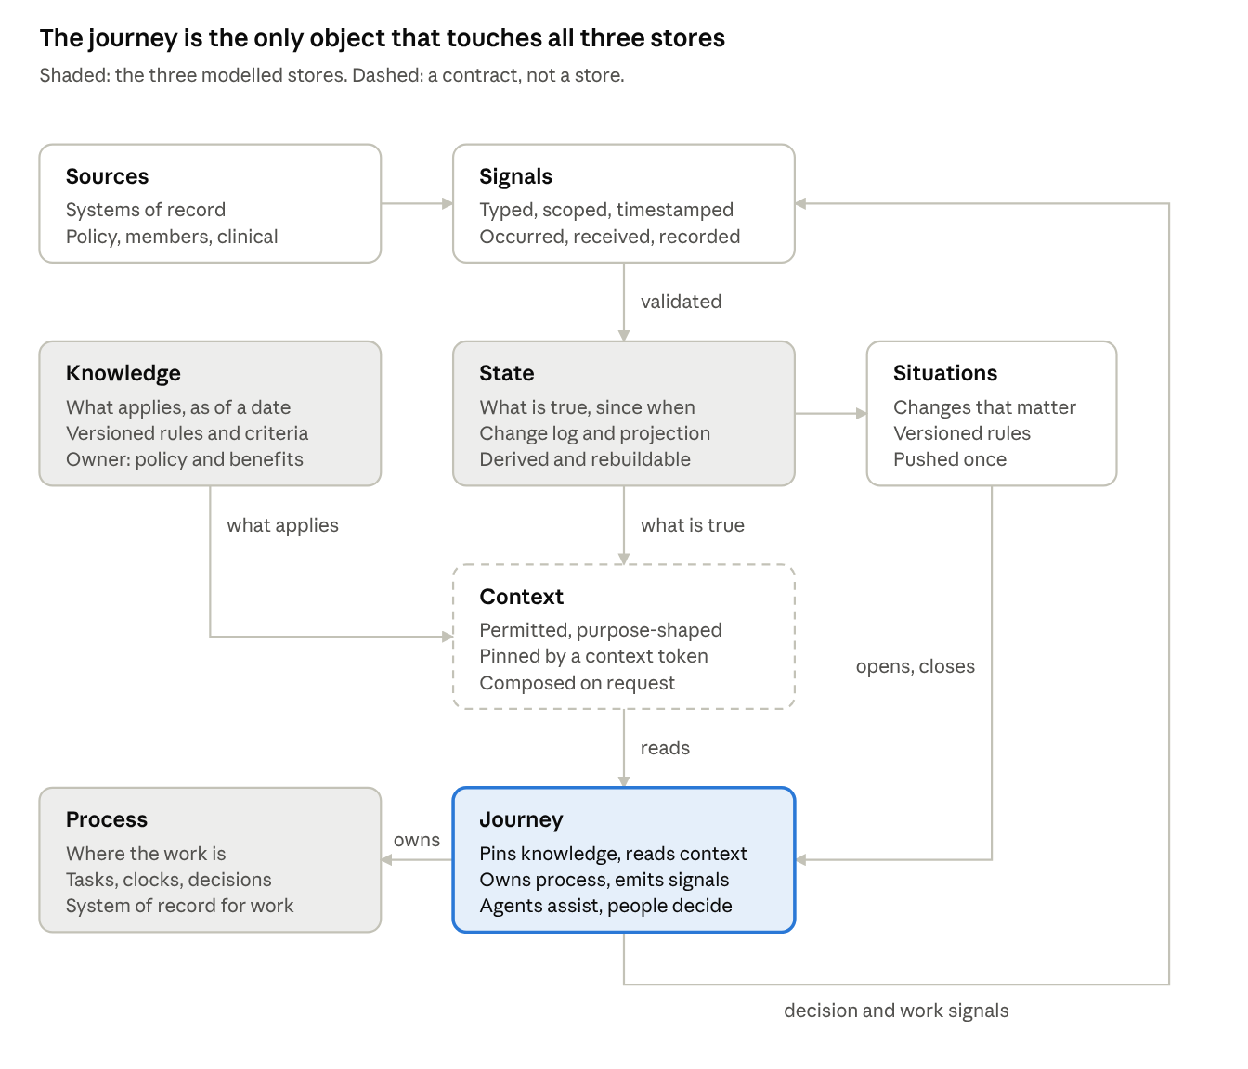
relationship spine · 3 stores, 1 contract, 1 feedback loop
- In. Sources emit events; SignalHub turns them into signals; validated signals become State.
- Detect. Each change in State is checked against situation rules; the ones that matter become situations.
- Compose. On request, Context combines Knowledge (what applies) with State (what is true), filtered for the caller and pinned by a token.
- Act. The journey reads context, situations open and close its work, and it runs that work in its own Process.
- Feed back. The journey sends decision and work signals back through SignalHub. That loop is how other journeys learn what was decided and what is in flight.
The same spine as relationships:
Member ─has→ Coverage ─in→ Plan ─offers→ Benefit ─subject to→ Rule (version) ─references→ Criteria (version)
Source ─emits→ Signal ─validated into→ State item ─about→ Member (+ case, provider, place)
State change ─detected by→ Situation (rule version) ─opens or closes→ Journey instance
Journey instance ─scoped to→ Member ─owns→ Tasks ─guarded by→ Clock (rule from Knowledge, start from State)
Agent ─reads→ Context (token: as-of moment + versions) ─composed from→ Knowledge + State + Situations
Agent ─proposes→ Recommendation ─reviewed by→ Person ─commits→ Decision ─emitted as→ Decision signal → State

Components in the picture
Eight boxes, each with one job and one owner. Three are modelled stores (Knowledge, State, Process); Context is a contract computed on request.
Component | What it is | Implemented by | System of record? | Reads | Writes or emits
Sources | Systems we already run: policy library, member data system (PRISM), clinical and case events, auth and appeals systems, facility feeds | Existing systems | Yes, for their own data | Their own stores | Raw events, files, extracts
Signals | Typed, scoped, timestamped facts, the only way into the layer | SignalHub: adapters, normaliser, dedupe and correlation, registry, stream | No | Raw source events | Signals on a member-partitioned stream
Knowledge | Versioned, member-independent rules and relationships | Knowledge service over the policy library and benefits configuration | Policy library and benefits configuration are; the service is a projection | Published policy versions | Nothing into member state
State | What is true for a member, since when, and how we learned it | StateHub: validation workers, change log, current-state projection, baseline reconciler, review queue | No; derived and rebuildable | Signals, baselines | Change-log entries, projections
Situations | Changes in state that matter to work | StateHub situation engine with versioned rules | No; derived | Change-log entries, work signals | Situation events
Context | A permitted, purpose-shaped, point-in-time answer | Context Hub behind the MCP gateway | No; computed, never stored | Knowledge, State, situations | Answers and context tokens, nothing else
Journey | A member-scoped unit of goal-directed work | Journey Intelligence Platform, plus UM systems (Phoenix, Vector) for UM cases | Yes, for work and decisions | Context, situations | Decision and work signals
Process | Tasks, waits, timers, clocks, milestones, case decisions | Inside each journey | Yes, inside the journey | The journey's own store | Through the journey only
What each arrow means.
Arrow | Meaning | Mechanism
Sources to Signals | Raw events are adapted into typed signals | Webhooks, queues, FHIR subscriptions, polling, document extraction
Signals to State (validated) | Accepted signals are appended to the member's change log | Validation workers, in order per member
State to Situations | Each change is evaluated against situation rules | Situation engine on the change stream
Knowledge to Context (what applies) | Rules resolved to a plan, a service and a date | what_applies
State to Context (what is true) | Current state, decisions and changes for a member | what_is_true_now, what_was_decided, what_changed(since)
Context to Journey (reads) | Journeys and their agents ask typed questions | MCP tools through the gateway
Situations to Journey (opens, closes) | A situation starts or ends journey work | Subscriptions, delivered at least once
Journey to Process (owns) | The journey runs its own work | Journey platform or UM system, not the layer
Journey to Signals (decision and work signals) | Decisions and work in flight become visible to everyone else | Published signal contract into SignalHub
Agents and people sit inside the journey. Agents read the hub and propose recommendations; people confirm decisions where required. Neither writes facts into State.

Technical architecture
The architecture keeps the v3 shape and makes the spine's loop explicit. Facts enter once through SignalHub and are reconciled once in StateHub. They are read only through the Context Hub, and journeys send decisions and work back the way they came.
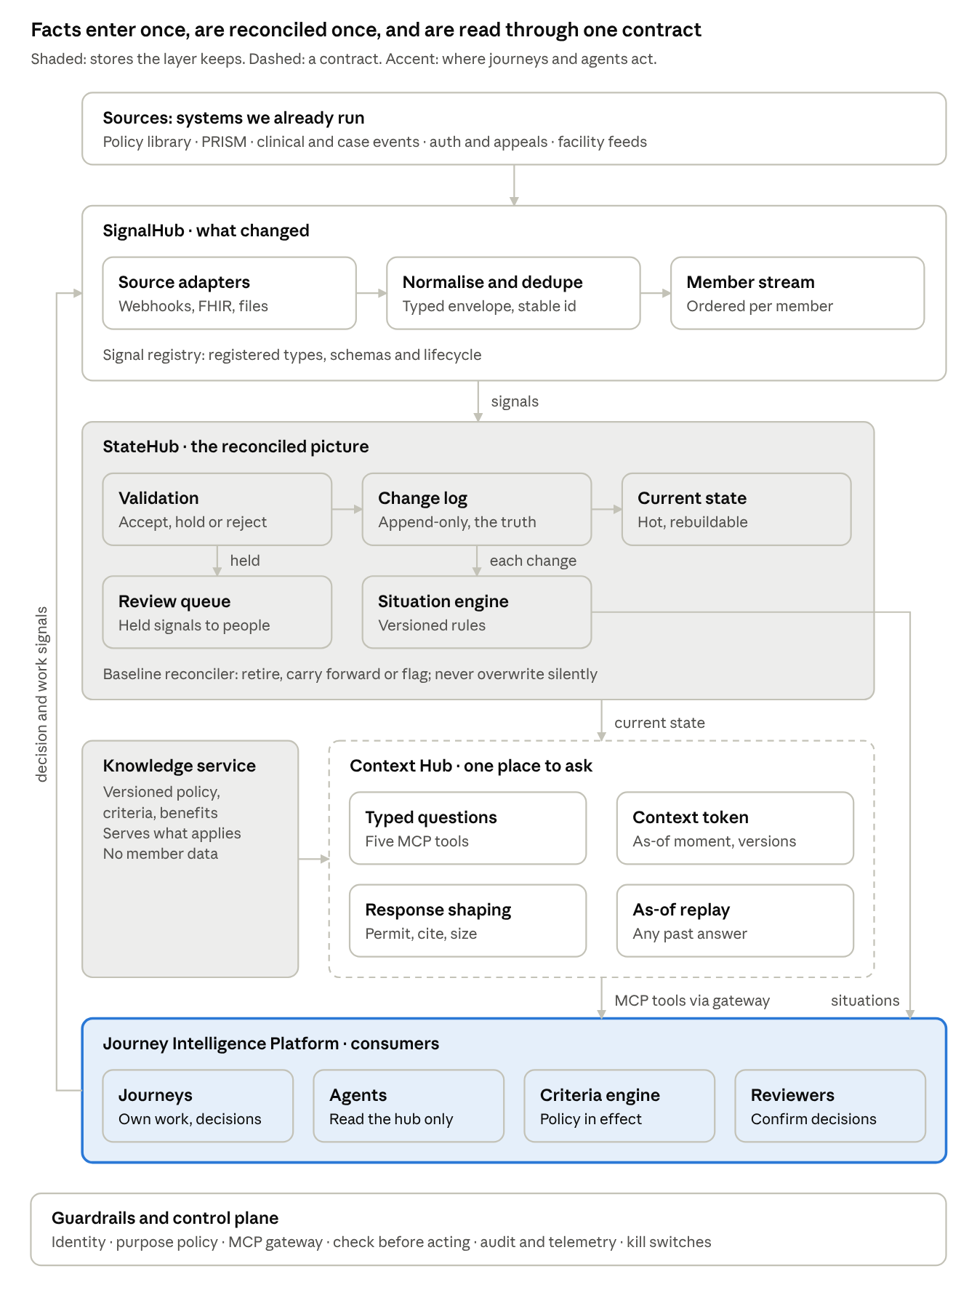
technical architecture · 4 services, 1 guardrail band
What this design adds to v3:
- Work signals from journeys, so the layer can show work in flight across journeys without becoming a workflow engine.
- Three timestamps on every signal, with received_at required on requests, so regulatory clocks are computed correctly.
- A full decision trace on every decision signal: reasons, criteria, evidence, versions, exception flag, AI-assisted flag and recommendation disposition.
- Provider and place scopes in the same log as member state, for gold-card status, network participation and facility alerts.

Core records
Six records carry the whole design. The sketches below are Python for readability; the wire format (Avro, Protobuf or JSON Schema) is an open decision.
from dataclasses import dataclass, field
from datetime import datetime
from enum import Enum
from typing import Any, Literal
class Kind(str, Enum): # how we know an item
OBSERVED = "observed"
REPORTED = "reported"
EXTRACTED = "extracted"
DERIVED = "derived"
ESTIMATED = "estimated"
@dataclass(frozen=True)
class Scope:
member_id: str # always present: the partition key
case_id: str | None = None
provider_id: str | None = None
place_id: str | None = None
@dataclass(frozen=True)
class SignalEnvelope: # the only way a fact enters
signal_id: str # stable across retries
revision: int # corrections are new revisions
signal_type: str # from the signal registry, e.g. "auth.status_changed"
family: Literal["event", "decision", "work", "place"]
scope: Scope
source: str # named system or person
occurred_at: datetime # when it happened in the world
received_at: datetime # when the organization received it; clocks start here
recorded_at: datetime # when we ingested it
sensitivity: frozenset[str] = frozenset() # e.g. {"part2", "behavioral"}
correlation_ids: tuple[str, ...] = () # links to other objects (case, auth, notice)
payload: dict[str, Any] = field(default_factory=dict)
@dataclass(frozen=True)
class StateItem: # one fact in the projection
item_key: str # e.g. "auth/A123/status"
value: Any # gaps are values: "no_record_received", "stale"
kind: Kind
valid_from: datetime # true in the world from
valid_to: datetime | None
recorded_at: datetime # when we learned it
sources: tuple[str, ...] # signal ids that assert it
model_or_rule_version: str | None = None # required for derived and estimated
sensitivity: frozenset[str] = frozenset() # inherited from inputs
@dataclass(frozen=True)
class Situation: # a change that matters
situation_id: str
situation_type: str # e.g. "auth.decided", "gap.closed"
rule_version: str
scope: Scope
status: Literal["active", "resolved", "obsolete"]
detected_at: datetime
triggered_by: tuple[str, ...] # state item keys or signal ids
@dataclass(frozen=True)
class DecisionTrace: # payload of a decision signal
decision_id: str
outcome: str # approved, denied, partial, pended
reason: str # specific reason; required when adverse
criteria_met: tuple[str, ...]
criteria_not_met: tuple[str, ...]
evidence: tuple[str, ...] # signal or document ids cited
policy_version: str
criteria_version: str
is_exception: bool
exception_approved_by: str | None
decided_by: str # accountable person or committed journey step
ai_assisted: bool
recommendation_ref: str | None
recommendation_disposition: Literal["accepted", "modified", "rejected"] | None
received_at: datetime
decided_at: datetime
notified_at: datetime | None
@dataclass(frozen=True)
class WorkSignal: # payload of a work signal: coarse, read-only view of work
journey_type: str # e.g. "prior_auth", "care_management"
journey_instance_id: str
event: Literal["opened", "assigned", "status_changed", "pended",
"extended", "decided", "notified", "commitment_made", "closed"]
canonical_status: str # shared vocabulary across systems
owner: str | None
due_at: datetime | None # the governing clock, if any
clock_rule: str | None
@dataclass(frozen=True)
class ContextToken: # pins a moment; not a credential
token_id: str
as_of: datetime
knowledge_versions: dict[str, str] # policy, criteria, measure spec, clock table
projection_watermark: int # last change-log offset included
purpose: str
expires_at: datetime
Three rules hold across all records: nothing is updated in place, every derived value names its rule or model version, and sensitivity tags carry forward to everything derived from them.

Interfaces
The layer exposes four interfaces: one way in, one way to ask, one way to be told, and one way to look back.
1. Ingestion (into SignalHub). Source adapters and journeys publish signals against a registered schema.
- Every signal has a registered type, a member scope, and a stable id plus revision, so retries are idempotent.
- Request signals (such as a prior authorization request or an appeal) must carry received_at, or they are rejected.
- Rejected signals go to a dead-letter queue with the reason. Implausible or conflicting ones go to the review queue for people.
- Journeys publish decision signals and work signals through the same contract as any source.
2. Typed questions (Context Hub, as MCP tools).
Tool | Inputs | Returns | Member data?
what_applies | Plan, service or measure codes, line of business, as-of date | Rules, criteria, clock rule, with versions | No
what_is_true_now | Member, topics (coverage, accumulators, authorizations, work in flight…) | State items with sources, timestamps, kind and freshness | Yes
what_was_decided | Member, plus case, service family or date range | Decision traces | Yes
what_changed(since) | Member, a context token or a timestamp | Changes and situations since that moment | Yes
what_changed_in_place | Place or area, since | Facility and area alerts | No
Every request carries the caller's workload identity, the delegated user, the purpose and the relationship to the member. Every response carries a context token, a summary, the items, stated gaps and evidence references, sized to a token budget.
3. Situation subscriptions (push). Journeys subscribe by situation type and scope filter. Delivery is at least once and ordered per member; consumers deduplicate by situation id. A subscriber receives each lifecycle change: active, resolved, obsolete.
4. As-of replay. Any typed question can be asked as of a past context token or timestamp. Answers are rebuilt from the change log and the baseline version in effect, so appeals, audits and evaluations see what was known then, with no hindsight.
Administration. The signal registry, the situation rule registry and the kill switches are managed interfaces with versioning, review and audit.

Key flows
Three flows exercise every component: a fact arriving, an agent asking, and a decision coming back.
A. Signal to state to situation
- A source adapter receives an event, maps it to a registered signal type, sets occurred, received and recorded times, and tags sensitivity.
- The normaliser builds the envelope; dedupe and correlation assign a stable id and revision and link related objects (case, authorization, notice).
- The signal is published to the stream, partitioned by member id.
- The validation worker for that partition asks: already known, newer or older, a correction, plausible for this member, and (for decisions) allowed and not in conflict? It appends to the change log or routes to the review queue.
- The projection updater applies the entry to current state, with valid time and record time.
- The situation engine evaluates its rules on the change and emits a situation event if one fires or resolves.
- Subscribed journeys receive the situation; one may open work.
B. An agent asks for context
- An agent in a journey calls what_is_true_now through the MCP gateway, carrying its workload identity, the delegated user, the purpose and the member.
- The gateway authenticates the caller. The policy engine checks purpose and relationship to the member and returns the permitted scopes and sensitivity filter.
- The Context Hub mints a context token, or reuses the one passed in: as-of moment, knowledge versions, projection watermark.
- It reads the projection at that watermark and, where needed, calls the knowledge service pinned to the same versions.
- Response shaping filters by permission, attaches sources and timestamps, states gaps, puts the summary first and sizes the answer to the budget.
- The gateway records who read what, for which purpose, in the audit trail and the trace.
- The agent reasons and writes a recommendation to the journey's audit trail, never to State.
C. A decision flows back
- A person reviews the recommendation and commits the decision in the journey's own system, which is its system of record.
- The journey emits a decision signal with its trace, plus work signals such as "decided" and "notice pending, due at".
- SignalHub ingests them; validation checks the decision is allowed and does not conflict with open work, such as a pending peer-to-peer.
- The change log records the decision and the open notice; the projection shows both.
- The situation engine publishes "decision reached", so other journeys, such as member service, see it.
- When the notice goes out, the journey emits "notified", and any "clock at risk" situation resolves.
Throughout flow C, the deciding journey reads its own work from its own system. It never reads it back through the layer, which trails it.

Storage and runtime
The change log is the layer's only durable truth; every other store can be rebuilt from it plus baselines. Candidate technologies below are options to fit our existing enterprise stack, not choices.
Store or runtime | What it must do | Access pattern | Candidate technologies
Signal stream | Order per member, replay, enforce schemas | Append, consume by partition | Kafka or a Kafka-compatible service, with a schema registry
Change log | Append-only, immutable, long retention for replay and audit | Append; read by member and offset | Stream with tiered storage plus a lakehouse table (Delta or Iceberg) as the durable copy; or an event store
Current-state projection | Fast reads by member, rebuildable | Point reads by member and topic | Relational or document database, with a cache in front
Baseline versions | Each member-data refresh kept with its version and cutoff | Bulk load; read during reconciliation and replay | Object storage plus lakehouse tables
Knowledge service | Versioned, effective-dated rules and criteria; retrieval | Lookup by plan, service and date; semantic search | Existing semantic layer, backed by temporal tables; vector or graph index as a projection
Situation engine | Evaluate versioned rules on each change; hold timers | Stateful stream processing | Flink or Kafka Streams; a DMN or rules engine for rule evaluation
Review queue | Route held and conflicting signals to people | Work queue with assignment | Existing case or work-queue tool
Audit and telemetry | Who read what, for which purpose; one trace per call | Append; investigate | OpenTelemetry traces plus an immutable audit store
Decision-trace graph view (later) | Traverse decisions, evidence and policy versions | Graph queries | Graph database or graph extension, fed from the change log
Feature store feed (later) | Point-in-time features with no hindsight | Batch and streaming as-of joins | Existing feature store, fed from the change log
Runtime shape. Adapters, the Context Hub and the gateway are stateless services that scale out. Validation workers and the situation engine are stream processors, one consumer per member partition, so each member's changes are applied in order. A projection is rebuilt by replaying the change log into a new copy and cutting over, never by patching in place.

Non-functional requirements
The layer is eventually consistent with its sources and journeys, and it says so on every answer. The targets below are proposals to validate in the source assessment, not commitments.
Requirement | Design response | Target
Consistency | Each answer reads one snapshot, pinned by the token's projection watermark. Journeys read their own work from their own system, never back through the layer. | Consistent snapshot per answer
Ordering | Signals are partitioned and applied in order per member. No ordering is promised across members. | Per-member order, always
Idempotency | Signal id plus revision on every signal; situation id for subscribers to deduplicate | Exactly-once effect on state
Freshness | Freshness is set per signal type; every item shows its age; stale is a value, not an omission | To set per consumer: seconds for live calls, minutes for outreach planning
Latency | what_applies and what_is_true_now sit on real-time paths (live calls, real-time prior authorization) | Proposed: p95 in the low hundreds of milliseconds
Clock correctness | Clocks are computed from received_at; request signals without it are rejected | No clock computed from ingestion time
Replay | Any answer can be rebuilt from its token, the change log and the baseline version | Deterministic; retention to match audit and appeal periods (to confirm)
Degradation | A down source yields stale or outstanding values, not silent gaps; kill switches per source, signal type and rule | Permissions fail closed
Scale | Partition count sized by member volume and peak signal rate | To size during the assessment

Security and governance
Every question and every journey action passes through the AI platform's guardrails and control plane. The layer adds member-level rules on top.
Control | What it enforces | Where it sits
Identity | A workload identity for each agent plus the delegated user; no shared keys | MCP gateway
Purpose and relationship | Access is role, plus purpose, plus relationship to the member (such as an assigned case), under minimum necessary. A claimed purpose grants nothing on its own. | Policy engine, called by the gateway
Segmentation | Sensitive categories (substance-use records under 42 CFR Part 2, behavioral and reproductive health) are tagged at ingestion and filtered at answer time | SignalHub tags; Context Hub filters
Inheritance | A derived item (a score, a summary, a situation) carries the restrictions of every input | StateHub
No facts from agents | Agents read the hub and write recommendations to journey audit only | Gateway permissions; no write tools exposed
Human decisions | No adverse determination by an agent alone; check before acting | Journey guardrails and hard rules
Audit | Who read what, for which purpose, with which token; provenance on every item | Audit store and traces
Kill switches | Disable a source, a signal type or a situation rule by configuration, in minutes | Control plane
Change governance | Signal types, situation rules and clock rules are versioned, reviewed and tested with as-of replay before release | Registries
Precedent and agent memory stay outside the layer, in a separately governed store, and never become member truth.

Open design decisions
Ten decisions remain. The "lean" column is the proposed starting position, to confirm with the teams named.
Decision | Options | Lean | Who decides
Signal wire format | Avro, Protobuf, JSON Schema | Avro or Protobuf, with a schema registry | Platform
Durable change log | Stream with tiered storage plus lakehouse table; dedicated event store | Stream plus lakehouse, reusing existing platforms | Platform, data engineering
Projection store | Relational, document, key-value with cache | Whatever our real-time services already run, with a cache | Platform
Situation engine | Stream processor with embedded rules; separate rules service | Stream processor that calls a DMN engine to evaluate rules | Platform
Shared work-status vocabulary | Map each UM system to one model; keep per-system statuses | One canonical model with a lossless mapping | UM operations, Phoenix and Vector owners
Clock rule table | Compliance; UM operations; platform | Compliance owns rules, platform runs them | Compliance, UM operations
Consent and segmentation | Reuse an existing service; build tagging in the layer | Reuse if one exists; confirm in the assessment | Privacy, security
Decision-trace graph view | Now; when a consumer needs traversal | Defer until appeals or audit needs it | Architecture review
Feature store feed | First release; later | Later, from the change log | Data science, platform
Token expiry and answer budgets | Fixed; per consumer class | Per consumer class, set during the pilot | Platform, journey teams

